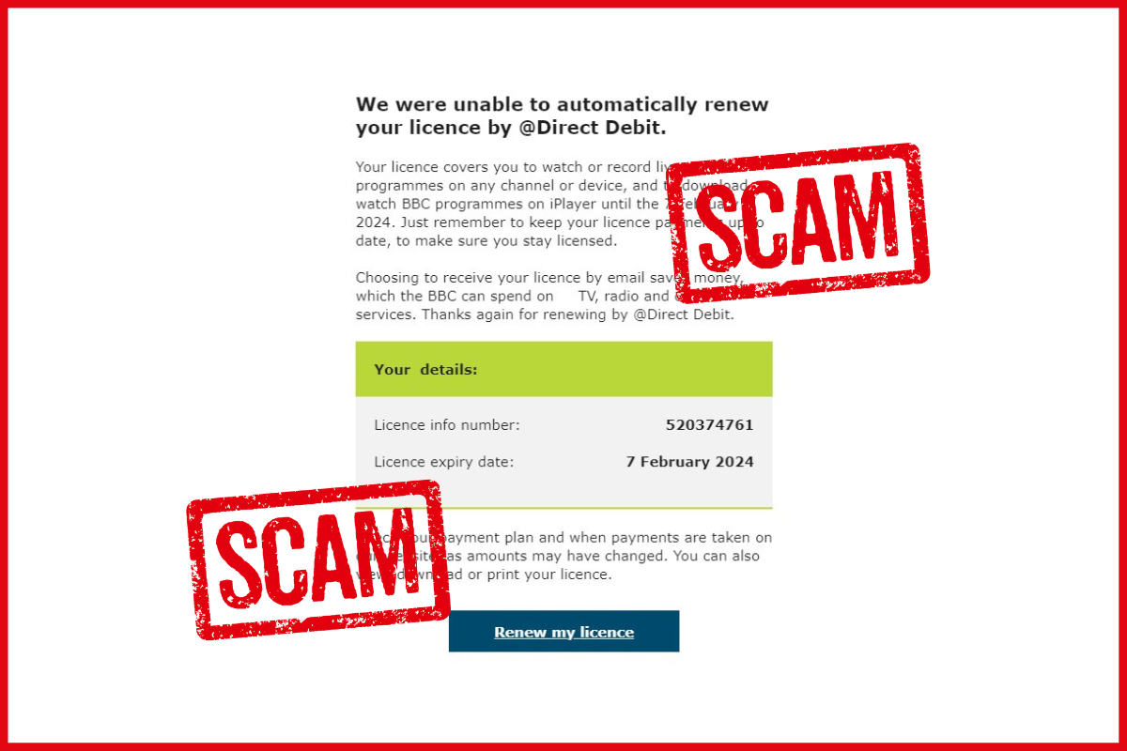
Beware of these fake TV Licensing emails!
The links within the email take you to a fake page created by fraudsters, designed to steal your personal information and money.
Forward scam emails to the National Cyber Security Centre on report@phishing.gov.uk.

